DU Simulator (DUSim) for Standalone (SA) and Non-Standalone (NSA) Mode, CU Tester: Setup and Installation Guide

Prepare the Hardware Platform for KVM Host:
Keysight’s “X100-5G” hardware platform is the validated platform that supports DU Simulator for both SA and NSA mode. Please follow below steps to prepare the KVM Host:
- Unbox your X100-5G, then connect the Keyboard, monitor, and mouse.
- Login into the system using user id catapult with password catapult and do the following command.
- Isolate host CPU and Enable PCI Passthrough using below steps-
sudo vi /etc/default/grub (Edit existing line to add new parameters below)

GRUB_CMDLINE_LINUX_DEFAULT="quiet splash video=vesafb:mtrr:3 isolcpus=1-21 nohz_full=1-21 rcu_nocbs=1-21 intel_iommu=on iommu=pt"
sudo update-grub
- Reboot the system
- X100-5G has Ubuntu OS installed from factory. If you re-installed a new OS, please type in the following command:
sudo /etc/catapult/configure_node.sh (change hostname if desired, enter number of 1G, 10G and 25G cards present on the PCI bus; the machine will reboot automatically)

Note: Supported NIC types are Intel Corporation 82599ES 10-Gigabit SFI/SFP+ and 25G Mellanox Technologies MT27710 Family [ConnectX-4 Lx].

Download VM image files and DUSim SA/NSA Packages Installer:
The next step is to download and install the required packages from the IxLoad software download portal to your X100-5G (to any directory):
- IxVM Image (IxVM Image for IxLoad 5G (KVM))
- DUSim VM Image (VM Image for IxLoad 5G DUSim (KVM))
- DUSim SA Package Installer
- DUSim NSA Package Installer
- This document

Deploy Virtual Machines (VM) on KVM host:
DU Simulator uses two VMs. One of the them is called DUSim HLS-VM (High level Split-VM) and other one is UE-VM. Downloaded item (2) and (1) in above are the VM’s Disk Image files.
Configure and deploy HLS-VM:
Copy compressed disk image file to KVM images directory and extract ‘HLS-VM.qcow2’ image file using below steps-
sudo cp DUSim_Virtual_Appliance_KVM.qcow2.tar.bz2 /var/lib/libvirt/images/
cd /var/lib/libvirt/images/
sudo su
tar xvf DUSim_Virtual_Appliance_KVM.qcow2.tar.bz2
Above step will extract below 4 files -
HLS-VM.qcow2
sample_domain_xml_HLS-VM.xml
sample_domain_xml_UE-VM.xml
sample_domain_xml_CoreSim.xml

The XML domain file for HLS-VM-
A sample XML domain file ‘sample_domain_xml_HLS-VM.xml’ is provided along with disk image file. The sample XML config assigns 16GB of memory, 19 CPUs and 4 network interfaces shown in picture below. Three of the network interfaces slot=0xa, slot=0xb and slot=0xc are SRIOV type interfaces. It is recommended to use SRIOV interface. The *last three slots must have fixed slot id mapping* i.e. F1-C port has slot=0xa, F1-U port has slot=0xb and slot=0xc to assign to a port that goes to same switch or PF(physical function) as UE-VM (that we’ll deploy next).

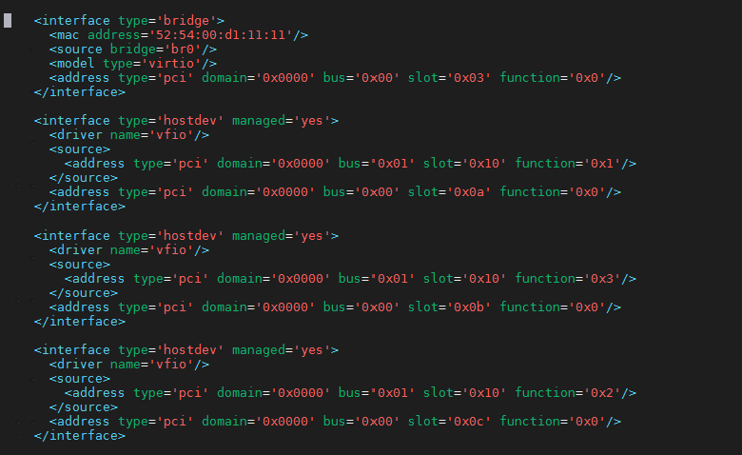
UE-VM Traffic Port (slot=0xc)
F1-U Port (slot=0xb)
F1-C Port (slot=0xa)
Management

Create SRIOV VFs on X100-5G & Edit the sample XML file to update SRIOV VFs information for last 3 interfaces:
e.g. eth6 for F1-C, eth7 for F1-U and eth2 for UE-VM & HLS-VM Traffic port. To create 2 VFs on each NIC port, edit below files and write the number of VFs “2” in the file.
sudo vi /sys/class/net/eth6/device/sriov_numvfs
sudo vi /sys/class/net/eth7/device/sriov_numvfs
sudo vi /sys/class/net/eth2/device/sriov_numvfs

List down PCI ID of VFs from eth6, eth7, and eth2.
sudo lspci | grep -i ethernet

Do assign a VF from eth6 to slot=0xa.
e.g. If VFs PCI-ID=01:10.1, the XML section for this interface below.
<interface type='hostdev' managed='yes'>
<driver name='vfio'/>
<source>
<address type='pci' domain='0x0000' bus='0x01' slot='0x10' function='0x1'/>
</source>
<address type='pci' domain='0x0000' bus='0x00' slot='0x0a' function='0x0'/>
</interface>

Same way assigns a VF from eth7 to slot=0xb & update sample XML file.
Also assign a VF from eth2 to slot=0xc and update sample XML file, the 2nd VFs from eth2 will be assigned to UE-VM.

Once the sample XML file is updated with the new interface information. We are ready to define and start the VM.
sudo virsh define sample_domain_xml_HLS-VM.xml
sudo virsh list --all
sudo virsh start HLS-VM

Open virt-manager tool & login to HLS-VM’s console with username catapult, password catapult
sudo virt-manager

Get IP address of br0 interface from Terminal
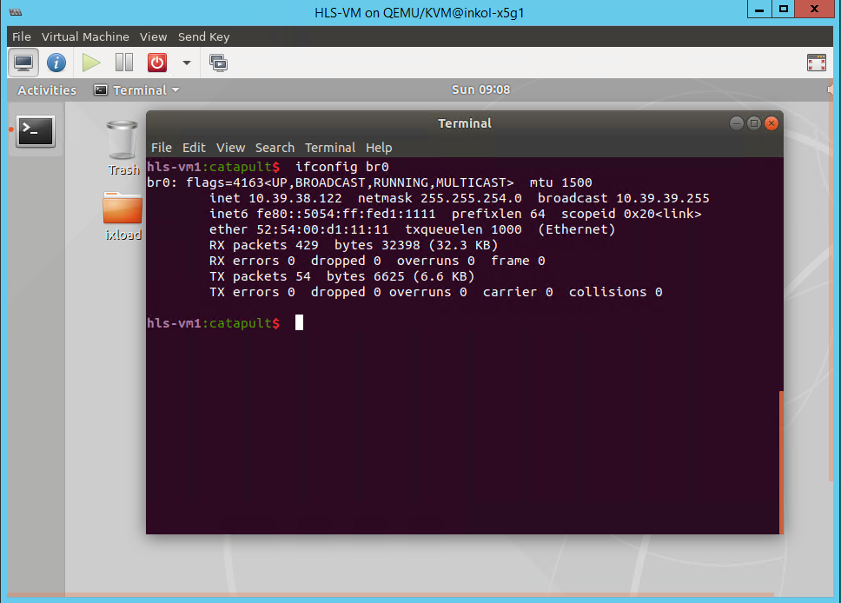

Configure and Deploy UE-VM:
Copy compressed disk image file to KVM images directory
sudo cp Ixia_Virtual_Test_Appliance_9.10_KVM.qcow2.tar.bz2 /var/lib/libvirt/images/
cd /var/lib/libvirt/images/
sudo su
tar xvf Ixia_Virtual_Test_Appliance_9.10_KVM.qcow2.tar.bz2
Ixia_Virtual_Test_Appliance_9.10_KVM.qcow2
sudo cp Ixia_Virtual_Test_Appliance_9.10_KVM.qcow2 UE-VM.qcow2

Open the sample XML domain file ‘sample_domain_xml_UE-VM.xml’ extracted earlier. Edit this XML file’s 2nd interface to add SRIOV interface e.g. from above HLS-VM example eth2’s (traffic port) other VF interface should be assigned here.
e.g. If the eth2’s other VF PCI-ID=01:10:0 then the interface section of XML is as below picture.
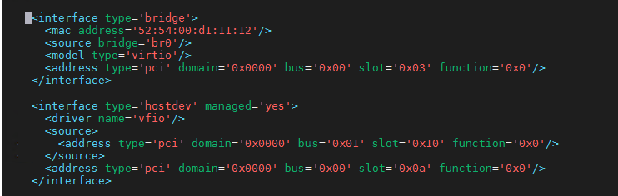
Traffic Port (towards HLS-VM)

Once the sample XML file is updated with the new interface information. We are ready to define and start the VM.
sudo virsh define sample_domain_xml_UE-VM.xml
sudo virsh list --all
sudo virsh start UE-VM

Open virt-manager tool to open console
sudo virt-manager

Get the Management IP address.
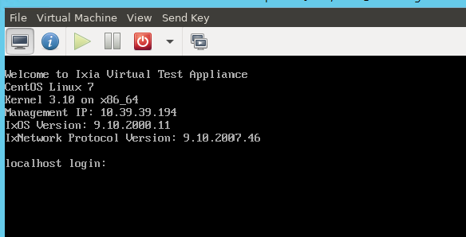

Configure and Deploy EPC or 5G Core Simulator VM:
Note: This is needed for the users who needs EPC Core or 5G Core (N1/N2/N3) needs to be simulated to test gNB-CU.
sudo cp Ixia_Virtual_Test_Appliance_9.10_KVM.qcow2 CoreSim.qcow2
Open the sample XML domain file ‘sample_domain_xml_CoreSim.xml’ extracted earlier. Edit this XML file’s 2nd interface to add SRIOV interface. It is recommended to use dedicated NIC port for this VM. So, use a different NIC than what were used for other VMs so far. The NIC can be a SRIOV VF NIC and assign the VF same way as UE-VM.
e.g. If the SRIOV VFs PCI-ID=82:10:0, then the XML’s interface section is below.
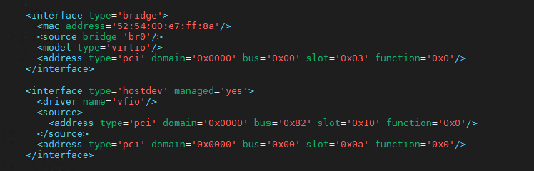
S1-C/S1-U
OR
N1/N2/N3

Once the sample XML file is updated with the new interface information. We are ready to define and start the VM.
sudo virsh define sample_domain_xml_CoreSim.xml
sudo virsh list --all
sudo virsh start CoreSim

Open virt-manager tool to open console
sudo virt-manager

Get the Management IP address.
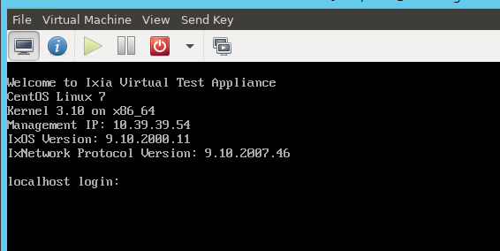

Install DUSim SA Package:
Copy the SA Package Installer (SA_DUSim_*.tgz) downloaded earlier [ item (3)] to HLS-VM’s /home/catapult/ixload/install/ directory.
scp SA_DUSim_*.tgz catapult@<HLS-VM’sIP>:/home/catapult/ixload/install/ (passwd: catapult)

Do SSH to HLS-VM using same credential as above and run below commands:
cd /home/catapult/ixload/install/
tar xvf SA_DUSim_*.tgz (this will extract 3 files)
chmod u+x hlssa_*_Installer.sh
./hlssa_*_Installer.sh

At this point when SA package is successfully installed, user is ready to configure and run test using IxLoad User Interface.

Install DUSim NSA Package:
NSA Package installer needs more than 10GB of free space. User need to add a second Disk in the HLS-VM. Follow below steps –
Add a seconds HDD (e.g. of size 30GB) from virt-manager.
Reboot the VM.
sudo fdisk -l (find new added hdd Disk e.g. /dev/sdb: 30 GiB)
sudo vgdisplay
sudo lvdisplay
sudo pvcreate /dev/sdb
sudo vgextend lvm-vg1 /dev/sdb
sudo lvextend -l +100%FREE /dev/lvm-vg1/root
sudo resize2fs /dev/lvm-vg1/root
df -h (check available free space now)

Copy the NSA Package Installer (NSA_DUSim_*.tgz) downloaded earlier [ item (4)] to HLS-VM’s /home/catapult/ixload/install/ directory.
scp NSA_DUSim_*.tgz catapult@<HLS-VM’sIP>:/home/catapult/ixload/install/ (passwd: catapult)

Do SSH to HLS-VM using same credential as above and run below commands:
cd /home/catapult/ixload/install/
tar xvf NSA_DUSim_*.tgz (this will extract 3 files)
chmod u+x ixloadInstaller_*.sh
./ixloadInstaller_*.sh
./dctInstall.sh

At this point when NSA package is successfully installed, user is ready to configure and run test using IxLoad User Interface.

