**IxLoad5GUEE VMs with eLSU Setup Guide**

This document provides IxLoad specific setup instructions and assumes eLSU is configured with basic cardmap and hwmap configuration

* Make physical connection between eLSU 10G ethernet port and Ixload VMs host machine

* Note the passthrough ethernet interface ID on eLSU and VMs host machine
  + Note: Refer to eLSU hwmap to ID the network interface ID

* **On eLSU** 
  + Configure NAT interface, the optional stack 2 and passthrough interface details
  + Navigate to /lsu/cfg folder
  + Edit cardmap file and add passthrough interface specific configuration

* OPT_STK <ppu> <stk_id> <io-pkt_variant> <prio[,opts]> <script>
* NAT_<stk instance> <ppu> <nat intf> <nat ip4> <nat mask> <defgw_ip4 or "-"> <V6>
* OPT_STK_ITF <ppu> <stk_id> <en_id> <net_itf_id> <alias_id> <script>
* PPU_CAPABILITY <ppu> PROCESS:<type>
* IP_ALIAS <ppu> <alias_id> <stk_id> <en_id> <ip_ver> <ip_addr> <prefix_len>

Note1: IP_ALIAS IPv4 address should be in the same subnet as UE IP (assigned by 4G/5G core network)

*Example (eLSU network interface ID 8 configured as passthrough with 192.168.3.7 as the interface IP):*

*OPT_STK 0-6 2 io-pkt-v6-hc 17*

*NAT_2 0-6 1 192.168.31.1 255.255.255.0 192.168.31.2 V6*

*OPT_STK_ITF 0-6 2 0* ***8*** *0 -*

*PPU_CAPABILITY 0-6 FUNC:IP_PASSTH 0 0*

*IP_ALIAS 0-6 0 2 0 4* ***192.168.3.7*** *24*

* **On Client PC (to run IxLoad GUI)**
  + Install AirMosaic version corresponding to the eLSU SW version (IxLoad uses AirMosaic in non-GUI mode)
  + Install compatible version of Ixload
  + Configure LTE, NR cells on eLSU via python web interface
  + Create Ixload test (configure eLSU IP under network group , stack settings) by using SA or NSA plugin
    - Configure stack settings
  + Add chassis, assign VM ports (IPs from VMs created on the host, see next section) and run the test
* **On host machine (for IxLoad VMs)**
  + Create VMOne VMs on host , select the eth interface corresponding to the passthrough connection during the VM creation
  + Refer to next section for specific instructions/steps to create VMs on Ubuntu based x5G or VMWare ESXI host
  + Use the VM IP as the chassis IP in the Ixload configuration

1. **Steps to create VMOne VM on ubuntu based x5g:**

1. Create the vm utils directory on the x5g:

mkdir -p /home/catapult/vm/utils

2. Copy vmutils.tgz to that directory and extract the files:

cd /home/catapult.vm/utils

tar zxf ./vmutils.tgz

3. A bridge is required in order to provide NETWORK MANAGEMENT capability to the host & VM via the eth0 interface.

Check that the bridge exists:

ifconfig br0

If not present, create the bridge with the following script:

sudo ./setupBridge.sh

This shows the two options

- The lab network operates in DHCP environment: use 'dhcp" for network configuration

- The lab network operates in static IP environment: enter the x5g host IP & netmask (assigned by lab manager)

Reboot the x5g

4. Copy the VMOne template to the x5g (suggested location is: /home/catapult/vm/tmp, but could be any location)

5. Create the VM:

The VM will be configured with a passthrough interface to the desired 10G/25G port in the backplane of the x5g for Control Plane/Data Plane testing

Run the script with no parameters to show the options

cd /home/catapult/vm/utils

./createVM.sh

Key options:

- name of the VM (no space no '.'). User's choice

- VM template location (where it was copied under 4. above)

- physical interface name to be used for testing (Control Plane/Data Plane). The list of available interfaces is provided.

- MANAGEMENT NETWORK parameters, which is used to connect to the VM from IxLoad. As for the bridge configuration, this is either:

dhcp

static IP (static IP, netmask & gateway)

Once created, the machine will reboot in order for the management network to take effect.

1. **Steps to create a VMone VM on VMWare:**

If using vSwitch, first create a vSwitch and a portGroup. VM Ports are assigned to port groups, and when the VM is created its vnics cannot be switched to another portGroup  
For simple case where a VM will have access to a physical nic, create one vSwitch and one portGroup for the new VM  
If using SR_IOV, there is no need for vSwitch/portGroups as the vnics will be a direct pci device

1. From a web browser, log into the VMWare host client web interface (url is just the management IP of the ESXi host)
2. Only if using a vSwitch, create it first:
3. Find the available vmnics. Look for 10G or 25G nics by listing the physical NICs. Here vmnic2 & vmnic3 are 10G (click on the name to get details)

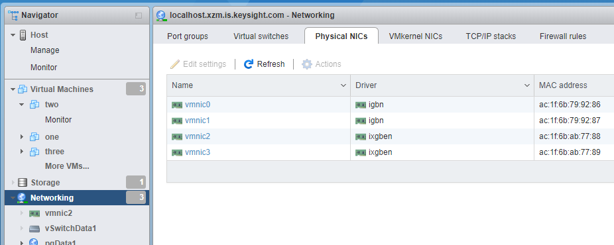

1. Create a vSwitch:  
   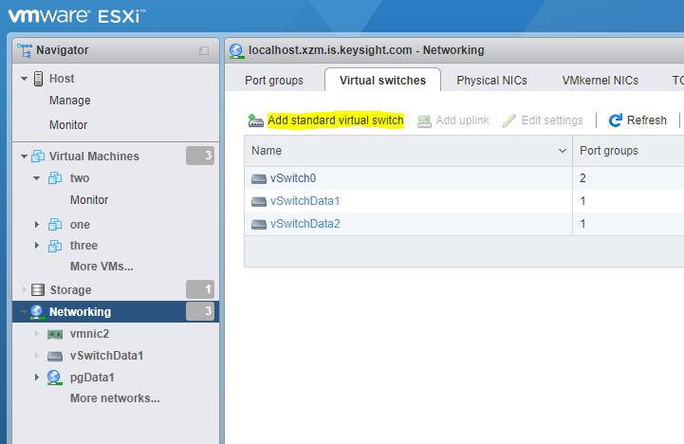

Name the vSwitch and select the vnic from the list that was shown above as the “Uplink 1”  
An additional nic could be added in this window (or later) if multiple nics were to be used

1. Create a new PortGroup

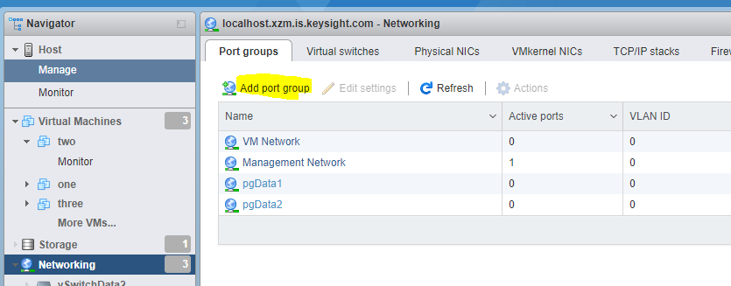

Give it a name, leave the vlan id as 0 and associate it with the previously created vSwitch

1. Create the VM. Select “Virtual Machines” top left, then “Create/Register VM”

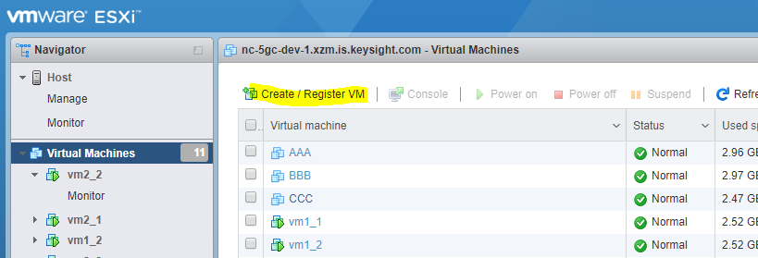

1. A new window pops up. Select Deploy a virtual machine from an OVA file

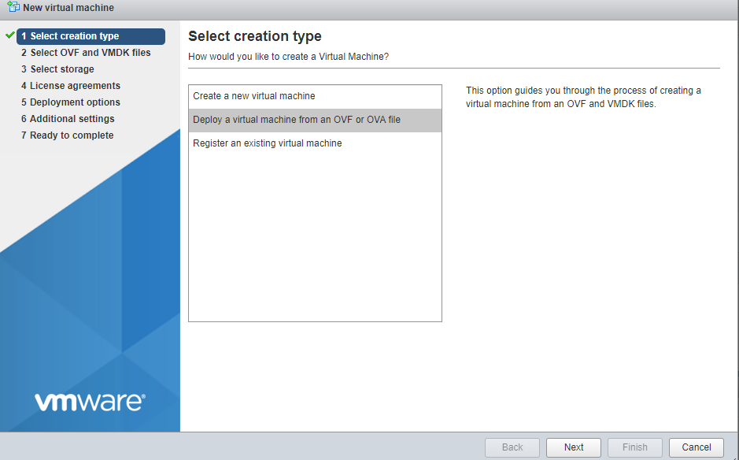

1. Enter a name for the new VM being created, and drag from a file explorer the Ixia_Virtual_Test_Appliance_9.00_ESXi.ova file into the blue box  
   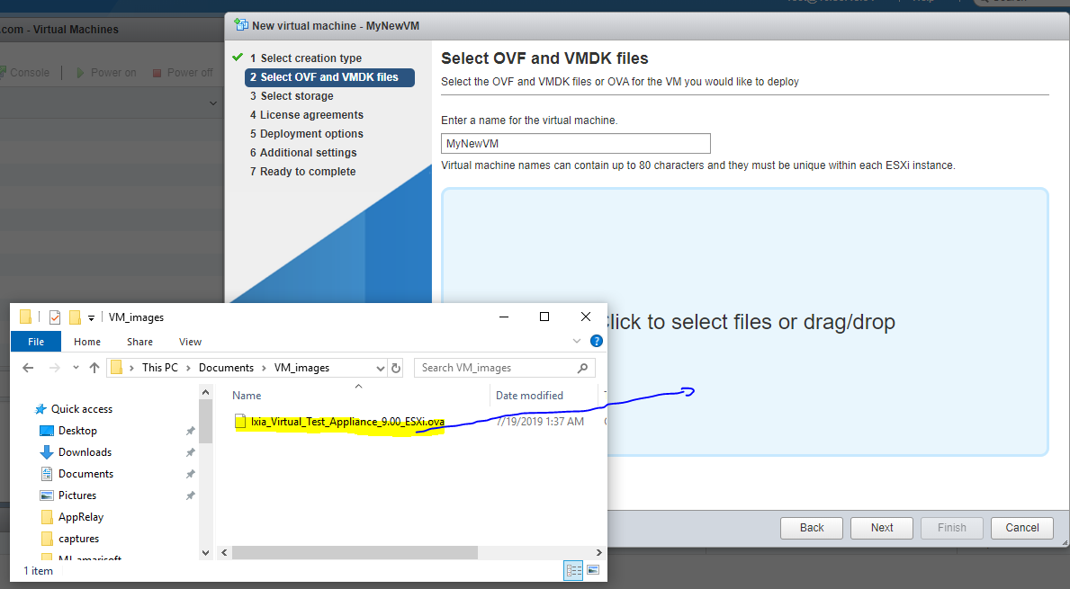
2. Use standard datastore
3. Agree to license agreement
4. Select VM Network for the Management Network
5. The VM comes by default with a “ManagementNnetwork” plus two “Test Networks”  
   Associate the Management Network with the VM Network, Associate the two Test Networks with the new PortGroup created

Use “thin” disc provisioning and di-select the “Power on automatically”. Select Next, then select “Finish”  
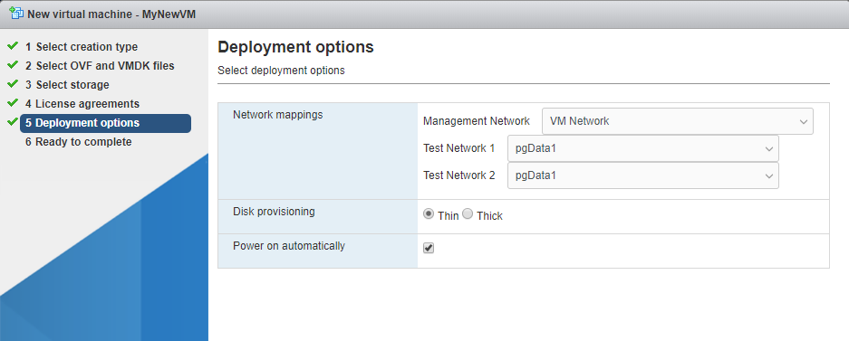

1. The VM gets created at that point. Wait for completion
2. When created, highlight the VM and edit the it.

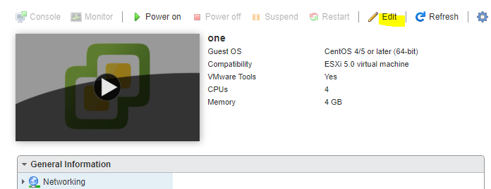  
  
a. If using vSwitch: remove Network Adapter 2

b. If using SR-IOV, Expand the Memory settings and add 4096 Reservation.

     Also remove the two Network Adapters and “Add other device” and select one of the PCI Ethernet controller from the desired nic

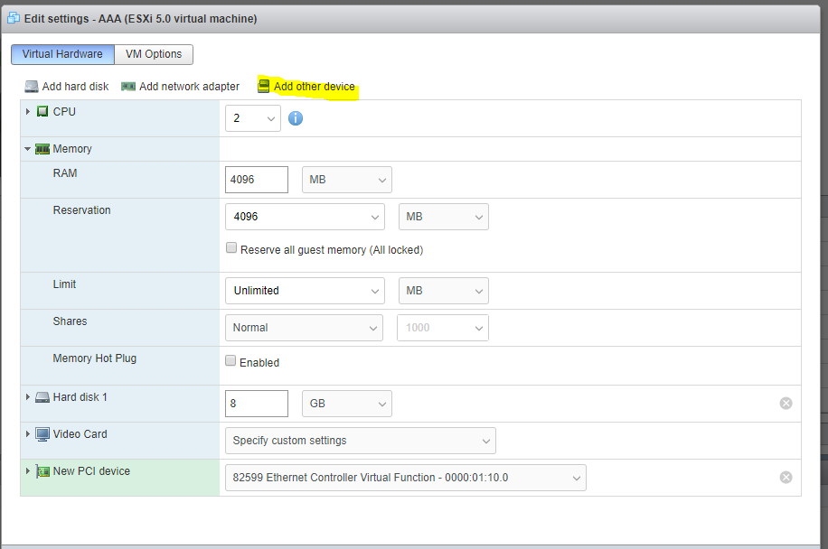

1. Start the VM. Connect to the console and find out management IP. This is the IP to use in IxLoad